**MOCK UPS**

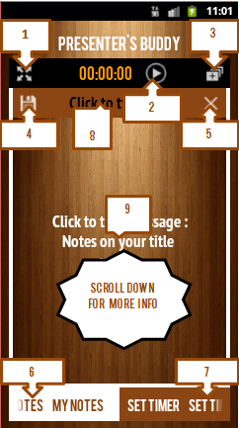

**"1. Press to view notes in full screen to revert back press back button on your phone "**

**"2. Press to play timer or pause timer "**

**"3. Press to add a new page to your notes. Slide the notes view from start page to view added note"**

**"4. Save page (VERY IMPORTANT) "**

**"5. Delete page "**

**"6. View notes tab "**

**"7. View timer tab "**

**"8. Click to enter title "**

**"9.Click to enter notes "**

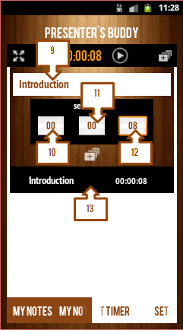

14141

**"9. Enter the name of a section of your presentation "**

**"10. Enter the number of hours you would wish to take on your presentation(format:00) "**

**"If one digit ensure there is a leading zero "**

**"11. Enter the number of minutes you would wish to take on your presentation(format:00) "**

**"If one digit ensure there is a leading zero "**

**"12. Enter the number of seconds you would wish to take on your presentation(format:00) "**

**"If one digit ensure there is a leading zero "**

**"13. Your stored section with time allocated displays as on this list "**

**"14. Add a new section to the list "**

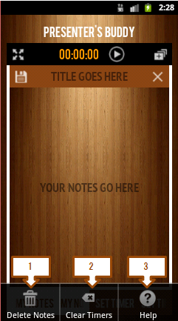

**"On clicking the menu you will find additional options which may assist in further modification of your presentation i.e "**

**"1. Delete notes "**

**"2. Clear timer: removes all items on section list "**

**"3. Help: displays this help page"**

**For tablets the views would stretch out the width**